Lab 3 Semiconductor Diodes

A pn junction is formed by fusing together semiconductor material doped with an excess of electrons called n-type, with semiconductor material doped with a deficiency of electrons (holes) called p-type. The letter 'n' stands for the negative, the sign of the electron charge and the letter 'p' stands for positive, the average charge in a region deficient in electrons. When the two types of material are butted together, a rearrangement of charge in the neighborhood of the junction causes a potential barrier to be formed between the 'n' and 'p' side. In order to conduct, majority charge carriers must overcome this potential. The magnitude of the potential wall V_{b} is a property of the undoped semiconductor material and for silicon V_{b} is about 0.6 volts.

In a real circuit, an external battery is used to modify the potential wall. In the reverse bias direction, the space charge increases, the width of the depletion increases and the effective potential as seen by the majority carriers becomes higher making it even more difficult for conduction to occur.

Figure 3-1 Energy level Diagrams for Reverse, Zero and Forward Biased Diode

In the forward biased direction, the opposite occurs. The effective potential wall reduces in height and conduction can occur. The magnitude of the conduction depends on the probability that the majority carriers can surmount the barrier height. This probability follows a Maxwell-Boltzman distribution, hence the conduction is exponential with the applied voltage.

The current I flowing through a pn junction can be approximated by the expression

I = I_{o} {exp(eV/ηkT) -1} Equation 3.1

where I_{o} is the reverse bias saturation current, e is the electron charge, V is the applied voltage, k is the Boltzman constant, T is the absolute temperature and η is a property of the junction material.

Let's look at the diode equation 3.1 in three different limits
1. Reverse Bias (V large and negative)
I = - I_{o} Equation 3.2
[In practice, I_{o} is a few microamps]

2. Forward Bias (V > 0.1 and positive)
I = I_{o} exp(eV/ηkT) Equation 3.3
[At room temperature, e/kT is about 40 Volts⁻¹ and I = I_{o} exp(40 V)]
and 3. Zero Bias (V~0 volts)
I = I_{o} (e/ηkT) V Equation 3.4
[In this limit, the exponential term can be expanded in a power series]
Comparing equation 3.4 with Ohm’s Law (V=IR), shows that the term (ηkT/eI_{o}) has units of resistance and its magnitude is a property of the diode. At other points, ΔV/ΔR or the (slope)⁻¹ on the [I-V] characteristic is called the dynamic resistance.

LabVIEW Demo 3.1 Current -Voltage Characteristic of a Silicon Diode.
Load the LabVIEW program Diode IV.vi. Ensure the power switch is on and then click on the [Run] button. Investigate the I-V characteristic of a silicon signal diode.

Figure 3-2 LabVIEW Simulation Circuit to Measure the [I-V] Characteristic Diode Curve

The voltage is applied to the diode by clicking on the controls of a Sweep Generator (variable power supply). Clicking on the [Fwd] or [Rev] buttons sweeps the voltage. In the Step mode, the buttons [Next ] and [Back], increment or decrement the applied voltage one step (0.02 volts) at a time. By clicking on the [Trails] switch, the individual current and voltage measurements will be marked on the graph.
The dynamic resistance R_{d} (ΔV/ΔI) is defined as the inverse of the tangent to the I-V curve at the operating voltage. In the forward biased region, the resistance is small and conduction occurs easily. In the reverse biased region, the resistance is very large and conduction is difficult. Switching the applied voltage polarity from + (forward bias) to – (reverse bias) is like switching a resistor from a low state to a high state. Investigate the dynamic resistance of the silicon diode by clicking on the [Show Rd] button and changing the operating point. The diode's ability to switch resistance from a high to low state was exploited in the early digital logic circuits employing combinations of diodes and resistors to build DRL (Diode-Resistor logic) devices.
What is the dynamic resistance at plus and minus 0.6 volts?
Semiconductor Diodes
When a junction is formed, some of the carriers in each material diffuse across the junction into the other side. That is, some of the electrons go to the p-type material and an equal number the holes go to the n-type material. This continues until the separation of charge forms a dipole layer near the junction, which in turn creates an electric field across the junction. At equilibrium no more current flows and a potential difference or barrier exists at the junction boundary. The magnitude of the potential barrier is a property of the host semiconductor material. For conduction to occur in the forward biased region of the I-V characteristic curve, the applied voltage must be greater than this barrier. Extrapolation of the I-V curve back to the voltage axis yields a threshold voltage which is close (within 10%) to the energy gap of the host semiconductor.

Figure 3-3 The [I-V] Characteristic Curves for Ge, Si and GaAs Diodes

For germanium the threshold voltage is 0.3 volts, for silicon the threshold voltage is 0.6 volts and for gallium arsenic the threshold voltage is 1.2 volts.

LabVIEW Demo 3.2 Forward Bias Properties

Load the LabVIEW program Diode2.vi from the chapter 3 program library. Ensure the power switch is on and then click on the [Run] button. This simulation plots the forward bias characteristics of diodes manufactured from three of the most popular semiconductor materials: silicon, germanium and gallium arsenic. Click on the thumb-wheel selector to change the material type. From the diagram make an estimate of the threshold voltage for each type.

Figure 3-4 LabVIEW Simulation of the [I-V] Characteristic Curve of Ge, Si and GaAs Diodes

It is clear from the diode equation that the current flowing through a diode depends critically on the ambient temperature. In the above simulation, the ambient temperature can be varied by dragging the temperature slider. Investigate the temperature dependence of the diode I-V characteristic curve.

LabVIEW Exercise: Using the Diode2.vi program, make a plot of the voltage across the silicon diode versus temperature at a constant current of 10 ma. This voltage level is strongly dependent on temperature. Do diodes make good thermometers?

LabVIEW Demo 3.3 Reverse Bias Properties
Load the LabVIEW program Diode3.vi from the chapter 3 program library. Ensure the power switch is on and then click on the [Run] button. This simulation plots the reverse bias characteristics for Zener and Avalanche diodes. Click on the thumbwheel selector switch to change the diode type.
A Zener diode is heavily doped so that at a particular reverse voltage, the diode will switch from a normally high resistance state to a low resistance state. In Diode3.vi, the Zener voltage is at -12 volts. Zener diodes are used in all types of circuits to limit voltage to a particular designer maximum value.
All diodes if pushed far enough into the reverse bias region will eventually breakdown in an avalanche mode. Free electrons are accelerated by the applied negative voltage to such a high velocity that on collision with an atom more electrons are freed which in turn are accelerated and collide with more atoms. As the process continues, the current rises exponentially and the diode will destroy itself unless the current is limited. A special type of diode called an avalanche photodiode exploits the avalanche charge multiplication to become a very sensitive light sensor.

The Photodiode
All diodes are light sensitive. The reverse biased saturation current depends on the density of free electrons and holes and for photodiodes I_{o} is called the dark current. Light shining onto a diode junction creates additional free electron-hole pairs. In reverse bias, large voltages can be applied to a diode. The free carriers are swept across the junction by the reverse voltage and result in a photocurrent. The magnitude of the current depends on the intensity of the light striking the junction region. Photodiodes are manufactured to optimize this effect.

﷈

Figure 3-5 The [I-V] Characteristic Curve for a photodiodeÝ
The I-V characteristic of a photodiode displays how light shinning on the diode junction shifts the characteristic curve away from the dark current curve. Photocurrents are in the microamp region, a factor of 1000 times smaller than currents flowing in the forward biased region. Precise measurements of light intensity require that the dark current to be subtracted from measured photocurrents.

LabVIEW Demo 3.4: The Photodiode [I-V] Characteristic Curve

Load the LabVIEW program PhotoDiode.vi from the chapter 3 program library. Ensure the power switch is on and then click on the [Run] button. This simulation plots the diode I-V characteristic curve as the intensity of a light source is varied. Click and drag on the [Light Intensity] slider. Note that the characteristic curve is also sensitive to the temperature. Precision measurements require that photodiodes be held at a constant temperature.

Simple Light Meter using a photodiode/op-amp
The photocurrent i_{p} is directly proportional to the applied light intensity I_{L}. The proportionality constant R is called the responsivity and its value depends on the wavelength of the applied light and the host semiconductor material.
i_{p} (μamp) = R I_{L}(μwatts) Equation 3.5

For silicon photodiodes, R = 0.5 μamp/μwatt at 680 nanometers.

Recall the transfer curve for the inverting op-amp, equation (1-5) V_{out} = - (R_{f} / R₁) V₁ . Equation 3.6
It can be written as
V_{out} = - (V₁/R₁) R_{f} = - i₁ R_{f} Equation 3.7
where i₁ is the current flowing in the input loop.

An op-amp configured in this manner is called a current-to-voltage converter. The output voltage is the product of the current flowing into the summing point times the feedback resistance. A photodiode is a current generator, hence the photocurrent i_{p} is the input current i₁ and the photodiode/op-amp transfer equation is just
V_{out} = - i_{p} R_{f} = - R I_{L} R_{f} Equation 3.8

LabVIEW Demo 3.5 Photodiode/Op-amp Photometer Properties

Load the LabVIEW program Photometer.vi from the chapter 3 program library. Ensure the power switch is on and then click on the [Run] button. This simulation plots the photometer response curve [Vout] versus [Light Intensity] as the intensity of a light source is varied. Click and drag on the [Light Intensity] rotary knob.

Figure 3-6 LabVIEW Simulation of a simple Light Meter using and Photodiode and Op-Amp

In general the photodiode characteristic curve is also sensitive to the temperature. Precision measurements require that photodiodes be held at a constant temperature.

LabVIEW Challenge: Design a LabVIEW program which includes the wavelength dependence of the Responsivity R into the simulation Demo 3.5. Over the visible region, R is approximately linear with values of 0.5 μA/μW in the deep red (680 nm) and 0.14 μA/μW in the deep violet (400 nm).
eLab Project 3
Objective: The objective of this electronic lab is to build an sensor circuit to measure light intensity.
Procedure: Build an op-amp current-to-voltage circuit shown in figure 3-6 or displayed pictorially below. The circuit requires a 356 FET input op–amp, a resistor, a photodiode and two power supplies. If a photodiode is not available, it can be replaced with a Light Emitting Diode. LEDs are efficient light sources when forward biased and can be used in reverse or zero bias as a photodiode.

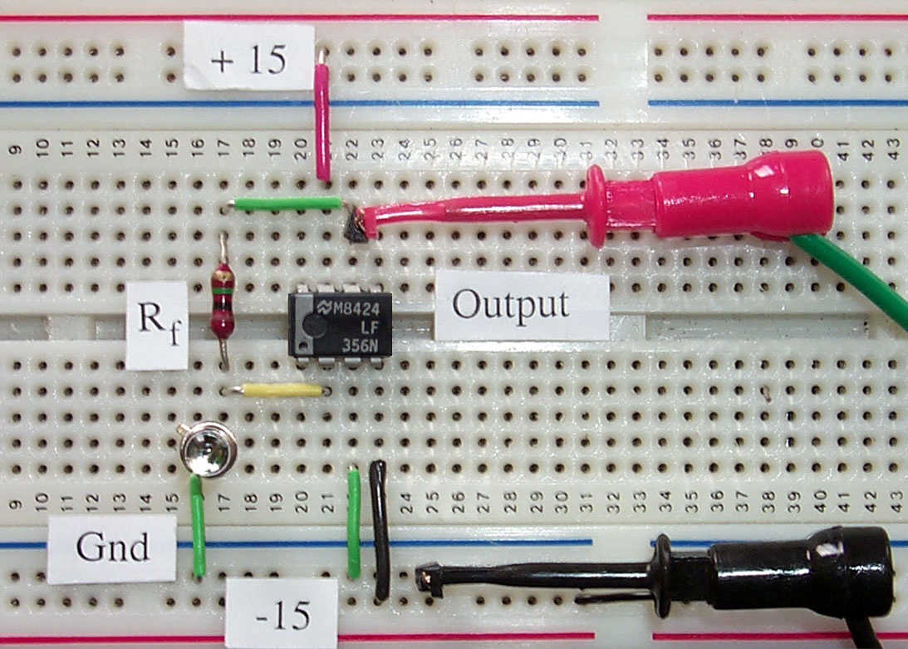
Figure 3-7 Component layout for Op-Amp Light Meter
Most photodiodes generate a photocurrent of a few microamps in a moderately bright light field. If R_{f} = 1MΩ, then the light meter output voltage will be a few volts.
Investigate the voltage output during sunrise, sunset, or the passage of clouds.

LabVIEW Challenge: Night-time Speed Detector
Place two light meters 100 feet apart along a busy road. As a car passes a detector, the voltage level will rise dramatically. Log the detector signals and measure the time between each rising signal. Dividing the elapsed time between detector rising signals into the distance between the detectors gives the speed of a passing vehicle.

Computer Automation 3 : I-V Characteristic Curve of a Diode

In assessing the characteristic properties of a device such a diode, a graphical representation of the current-voltage [I-V] curve under various input conditions completely defines the operation of the device. Computer automation allows a range of test signals under a variety of conditions to be output to the device under test. The measured response together with the input conditions can be displayed and analyzed. In this lab, we look at the I-V characteristic curve for a diode under test as one of the environmental conditions (temperature or light intensity) is varied.

Launch the LabVIEW program entitled TestDiode.vi from the chapter 3 library. This program uses an output channel on the DAQ card to generate DC test signals for the automated testing a diode circuit similar to figure 3-4. The scan range, rate and number of test points can be selected from front panel controls. Two input channels on the DAQ card measure the current and voltage of the photodiode at the operating point. The program displays the family of transfer curves on a front panel graph. To save a test set in a spreadsheet format, click on the [Save Data] button.

Connect the diode and current limiting resistor to the DAQ output. In most cases, the DAQ output will have to be buffered to provide the required current at the maximum forward biased limit. Chose a resistor value of (<1 kΩ) so as to produce a voltage signal in the 1-5 volt range when the diode is forward biased. Click on [Run] to observe the transfer characteristic curve.

LabVIEW Enhancements
Change the operating temperature and collect a family of [I-V] curves.
Use a LED to illuminate a photodiode and collect a family of curves
in the reverse bias region.

